**Outline:**

* Introduction
* Scenario
* ER diagram
* Normalization
* Table Creation
* Constraints
* Query Question
* Relational Algebra

**Scenario:**

Forrest Gump is an chronic gamer .He is known as “**GAMER**” in the online community. He has a gaming account with an unique GAMER ID , an user name and the account also include his age. Gamer has their own city and country. One day he was curious to know how the gaming industry work . He was amaze to learn the way this industry works. Almost all games are sold by Big . Every **companies** has there unique company id,company name, and their year of activity. But games are made by **developer** who works for the big companies because of lucrative pay cheque the companies offer. But like the companies developers also have an unique DEVELOPER ID ,developer name and their proud years of activity . With the permission of the companies developer sells game in different **game stores** .Every game stores has an Unique name , and supports a wide range of **devices** . Every gaming devices has an uniquedevice name**,** and common **OS** and some average amount of both RAM and ROM . With the help of internet devices can be used to downloadgames from the game store. And like most people gamer **purchased** the devices to play games.A **game** has a Unique name, install file , VRAM, passwordto enter the game. Every gamer will play the game. And this is how Forrest Gump understood how the gaming industry works.

**Normalization**

Play=(G-name,G-login,G-install,GM-id,GM-Name,GM-age,GM-mail,City,Country)

1NF :GM_Mail is multivalued attribute

2NF :G-Name,G-login,G-install

GM-id,GM-Name,GM-Age,GM-Mail,City,Country

3NF :G-Name,G-login,G-install

GM-id,GM-Name,GM-Age,GM-Mail

CT-id,City,Country

Tables for Play:

1. G-Name,G-Login,G-install, GM-id , CT-id
2. GM-id,GM-Name,GM-Age
3. GM-id, , GM-Mail
4. CT-id,City,Country

Purchase=(GM-id,GM-name,GM-age,GM-mail,city,country,D-Name,D-OS,D-ram,D-rom,D-type)

1NF : GM-mail is a multivalued attribute.

2NF :GM-id,GM-name,GM-age,GM-mail,city,country

D-name,D-OS,D-ram,D-rom,D-type

3NF :GM-id,GM-name,GM-age,GM-mail

CT-id, city,country

D-name,D-OS,D-ram,D-rom,D-type

Tables for Purchase:

1.GM-id, GM-name, GM-age, CT-id, ,D-name

2.GM-id, GM-mail

3.CT-id,city,country

4.D-name,D-OS,D-ram,D-rom,D-type

Downloads=(D-name,D-OS,D-Ram,D-Rom,D-type,GS-Name, GS-Type)

1NF:No multivalued attribute

2NF: D-name,D-OS,D-Ram,D-Rom,D-type

GS-Name, GS-Type

3NF:No transitive dependency

Tables for Downloads:

1. D-name,D-OS,D-Ram,D-Rom,D-type
2. GS-Name, GS-Type, D-Name

Sold = (GS_ name, GS_type, DE_name ,DE_id, salsary)

1NF: No multi valued attribute .

2NF :GS_name ,GS_type

DE_id ,DE_name, salary,year of activity

3NF: No transitive dependency

Table of sold :

1.GS-name ,GS_type

2. DE-id ,DE_name, salary , year of activity

3. N-id ,GS_name, DE_id

PAY CHEQUE =(DE_name ,DE-id , salary, Year of activity, c-id, c_name, c_experience)

1NF: No multi valued attribute

2NF :DE-id , DE_name , salary, Year of activity, c-id , c_name, c_experience

3 NF: No transitive dependency

Table for Pay cheque:

1. DE-id , DE_name, salary, Year of activity, c_id
2. C-id , C_name, C_experience

|  |  |  |
| --- | --- | --- |
| No | Tables Name | Columns |
| 1. | Game | G-Name,G_login,G_install, GM-id, Ct_id |
| 2. | Gamers information | GM-id,GM_Name,GM_Age, CT_id, , D_Name |
| 3. | Gmail | GM_id ,GM-mail |
| 4. | City | CT-id,City,Country |
| 5. | Device | D-Name,D-OS,D-Ram,D-Rom,D-type |
| 6. | Game Store | GS-Name,GS-Type ,D-Name |
| 7. | Developer | DE-id,DE-Name,Salary,Year of activity,C-id |
| 8. | Game Development | N-id, GS-Name ,DE-id |
| 9. | Company | C-id,C-Name,C-experience |

**ER diagram:**

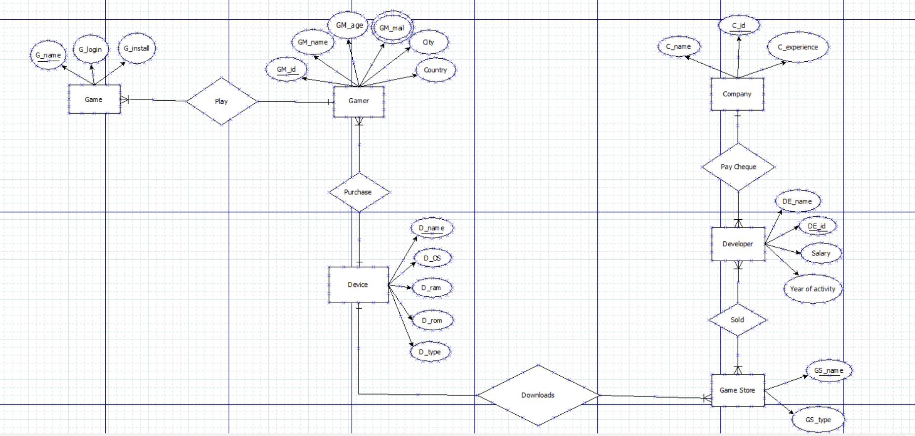

**Table Creation:**

**1.Game:**

Descgame_a

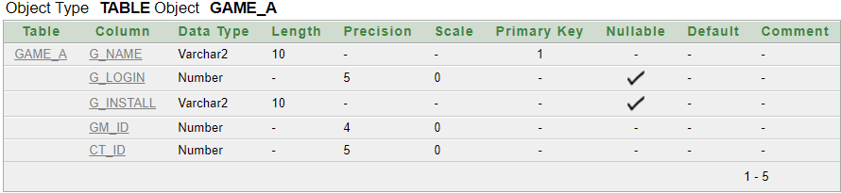

select * from game­_a

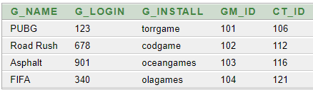

**2.Gamer’s information:**

Descgamers_information

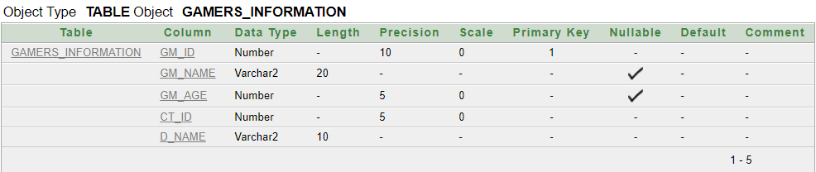

Select * from gamers_information

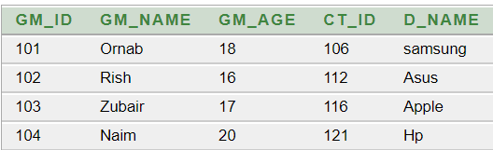

**3.Gamer’s Gmail:**

descgamers_gmail

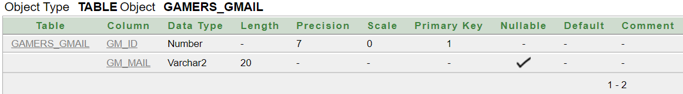

select * from gamers_gmail

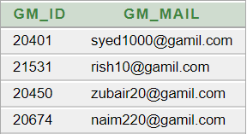

**4.City:**

Desc City

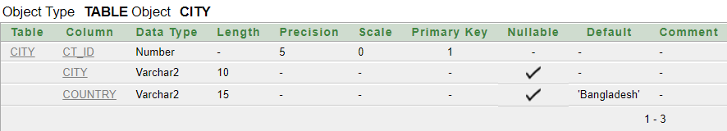

select * from city

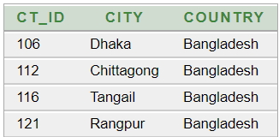

**5.Device:**

desc device

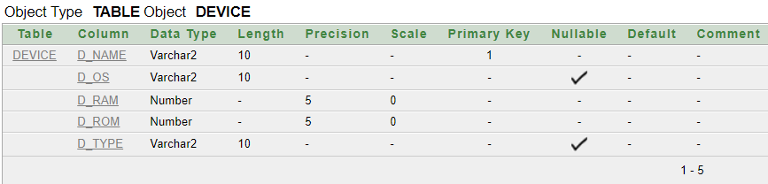

select * from device

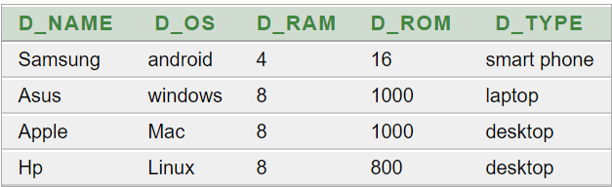

**6.Game Store:**

descgame_store

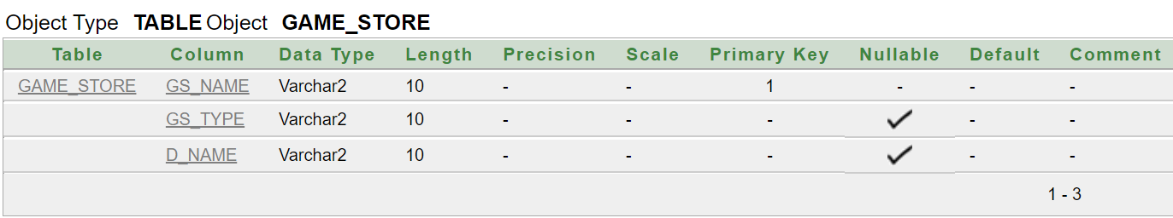

select * from game_store

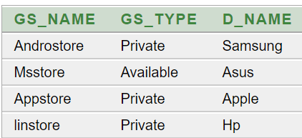

**7.Developer:**

Descdeveloper_a

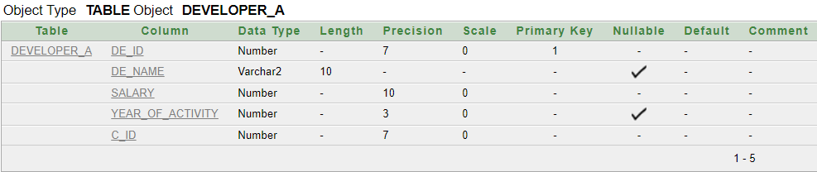

select * from developer_a

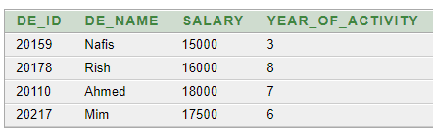

**8.Game Development:**

descgame_development

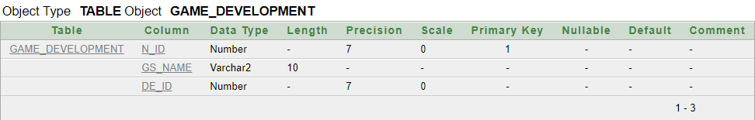

select * from game_development

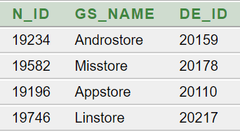

**9.Company:**

desc company

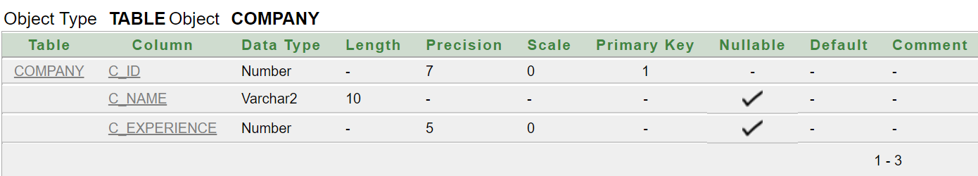

select * from company

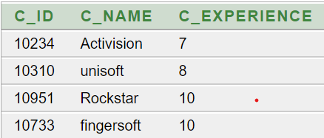

**Constraints:**

alter table game_a add constraint g1 primary key(g_name)

alter table game_a add constraint g220 foreign key(gm_id) references gamers_information(gm_id)

alter table game_a add constraint g123 foreign key(ct_id) references city(ct_id)

alter table game_a modify (gm_id not null)

alter table game_a modify (ct_id not null)

alter table gamers_information add constraint g6 primary key(GM_id)

alter table gamers_information add constraint g4 foreign key (ct_id) references city(ct_id)

alter table gamers_information add constraint f4 foreign key(d_name) references device(d_name)

alter table gamers_information modify (ct_id not null)

alter table gamers_information modify (d_name not null)

alter table game modify(ct_id not null)

salter table game modify(gm_id not null)

alter table game_development add constraint t11 foreign key(gs_name) references GAME_STORE(gs_name)

alter table gamers_gmail add constraint g70 primary key(gm_id)

alter table city add constraint g80 primary key(ct_id)

alter table city modify country default 'Bangladesh'

alter table device add constraint g90 primary key(d_name)

alter table device modify(d_rom not null)

alter table device modify(d_ram not null)

alter table game_development add constraint t11 foreign key(de_id) references developer(de_id)

alter table game_development modify (de_id not null)

alter table game_store add constraint g91 primary key(gs_name)

alter table game_store add constraint t3 foreign key(d_name) references device(d_name)

alter table developer_a add constraint g91 primary key(de_id)

alter table developer_a add constraint t50 foreign key(C_ID) references company(C_id)

alter table developer_a modify(salary not null)

alter table developer_a modify(c_id not null)

**Queries**:

1. Find the gamers who have a game id and also playing pubg?
2. Find the gamers name who playing games in sumsung?
3. Find Device operating system and game store type who have a device name?
4. Display all the developers name who have an id number and salary is greater then 15000?
5. Find the developer who work more than 7 years?
6. Find the city of all the gamers who have a device, a country or both of them.
7. Find the name of the game stores whose operating system is android.
8. Find the name of the developers and companies from the Developer and Company.
9. Find the name of the developer whose salary is greater than 17500.
10. Find the name of the developer who works in unisoft.

Relational Algebra:

1.πgm_name[σg_name=pubg][σgame.gm_id=gamers_information.gm_id(**gamers_information x game**)]

2. πgm_name[σd_name=sumsung](gamers_information)

3.πd_os,gs_typ[σdevice.d_name=game_store.d_name(**device x game_store**)]

4.πDe_name[σsalary>15000][σdeveloper.de_id=game_development.de_id]

5.πde_name[σstartdate-sysdate](developer)